AWS Auto Scaling

Tasks Covered
1. Create one VPC in N. Virginia Region.
2. Create two subnets: one public subnet and one private subnet.
3. Attach an Internet Gateway (IGW) to the VPC.
4. Create one public route table and one private route table.
5. Deploy a NAT Gateway in the public subnet and attach it to the private subnet's route table.
6. Create two EC2 instances — one in the public subnet, one in the private subnet.
7. Deploy Apache on both instances with a sample index.html.
8. Create an Application Load Balancer and attach it to both EC2 instances.
9. Store ALB access logs in S3.
10. Store VPC Flow Logs in a CloudWatch Logs group.
11. Create monitoring dashboards for CPU utilization and the Apache service.
12. Trigger Auto Scaling to launch a new instance when CPU utilization exceeds 70%.

Prerequisites
- An AWS account with console access to VPC, EC2, ELB, Auto Scaling, S3, CloudWatch, and IAM.
- An EC2 key pair for SSH access (or use EC2 Instance Connect / Session Manager).
- Basic familiarity with SSH and Linux commands for installing Apache.
Naming/CIDR plan used throughout this guide:
Resource | AZ | CIDR / Detail
Lab-VPC | us-east-1 | 10.0.0.0/16
Public-Subnet-1 | us-east-1a | 10.0.1.0/24
Private-Subnet-1 | us-east-1a | 10.0.2.0/24
Public-Subnet-2 (added in Task 8 for ALB's multi-AZ requirement) | us-east-1b | 10.0.3.0/24

TASK 1: Create One VPC in N. Virginia Region

Step 1.1 — Set the Region
1. Log in to the AWS Management Console.
2. Region selector (top-right) → select US East (N. Virginia) us-east-1.

Step 1.2 — Create the VPC
1. Search for and open the VPC console → Your VPCs → Create VPC.
2. Select VPC only.
3. Name tag: Auto-VPC. IPv4 CIDR block: 10.0.0.0/16 (manual input). IPv6 CIDR block: No IPv6 CIDR block. Tenancy: Default.
4. Click Create VPC. Note the VPC ID (vpc-xxxxxxxx).
✅ Task 1 Complete: Lab-VPC exists in us-east-1 with CIDR 10.0.0.0/16.
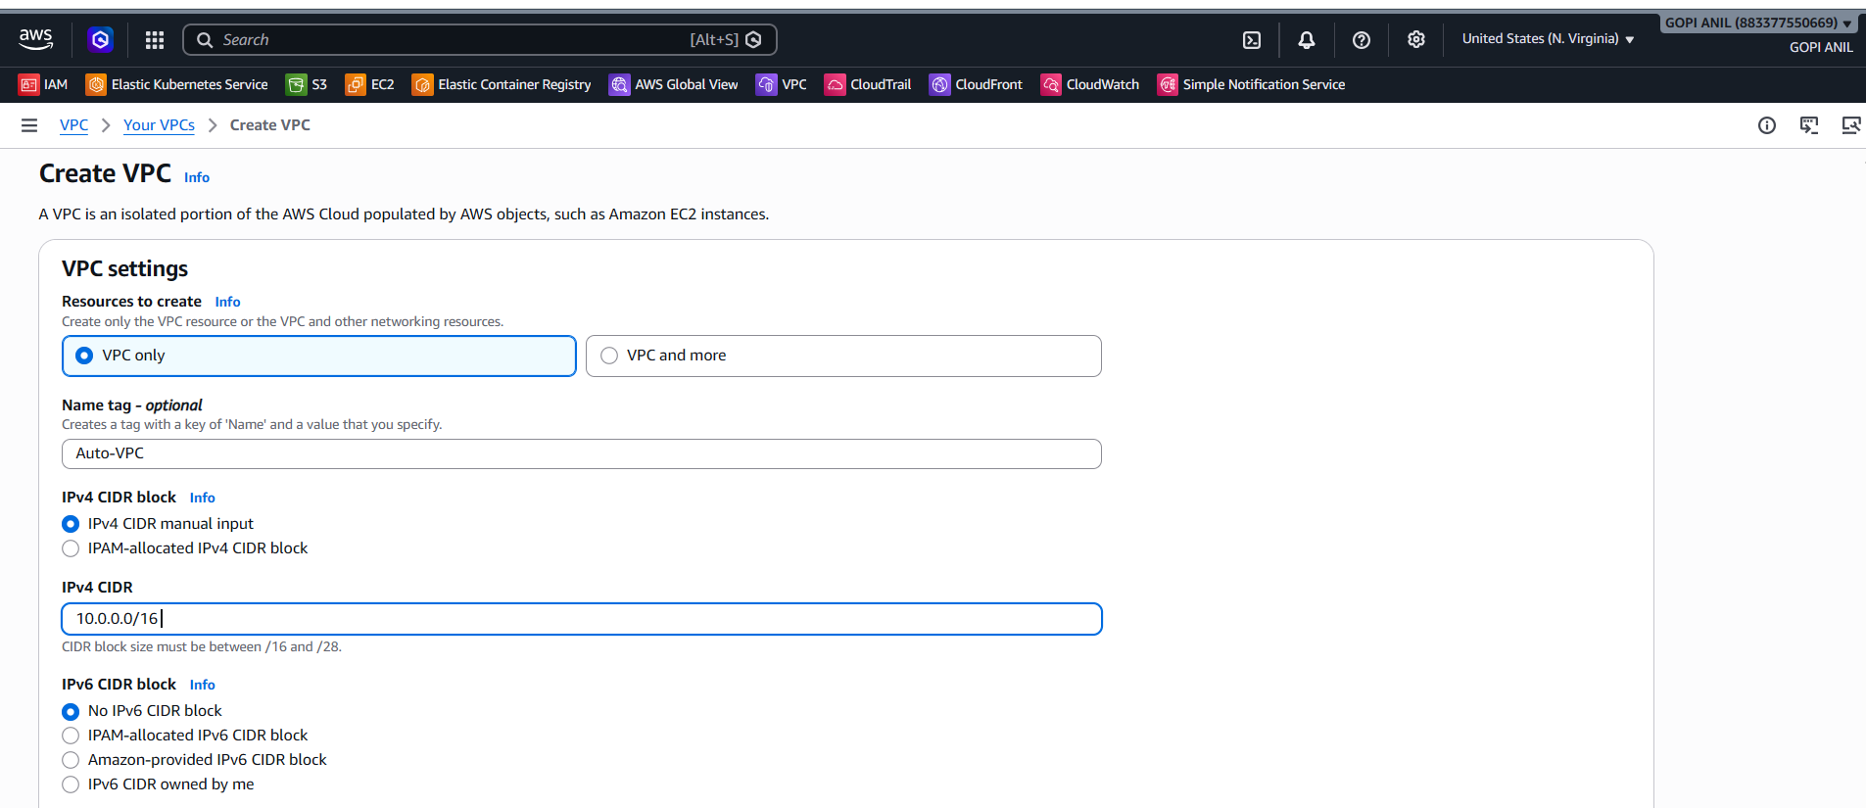
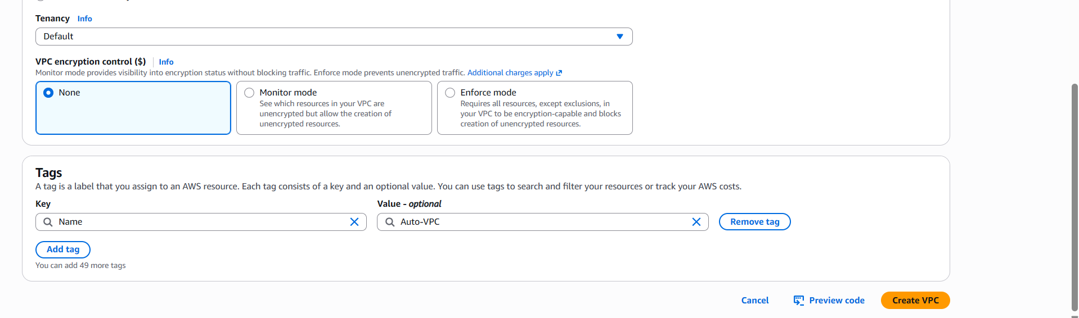
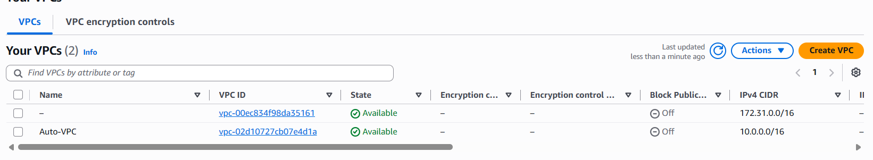

TASK 2: Create Two Subnets — Public and Private

Step 2.1 — Create the Public Subnet
1. VPC console → Subnets → Create subnet.
2. VPC ID: Auto-VPC.
3. Subnet name: Public-Subnet-1. Availability Zone: us-east-1a. IPv4 CIDR: 10.0.1.0/24.
4. Click Create subnet.
5. Select Public-Subnet-1 → Actions → Edit subnet settings → check Enable auto-assign public IPv4 address → Save.

Step 2.2 — Create the Private Subnet
1. Create subnet again.
2. VPC ID: Lab-VPC. Subnet name: Private-Subnet-1. Availability Zone: us-east-1a. IPv4 CIDR: 10.0.2.0/24.
3. Click Create subnet. Leave auto-assign public IP disabled (default) — this subnet stays private.
✅ Task 2 Complete: Public-Subnet-1 (auto-assigns public IPs) and Private-Subnet-1 (no public IPs) both exist in Lab-VPC.
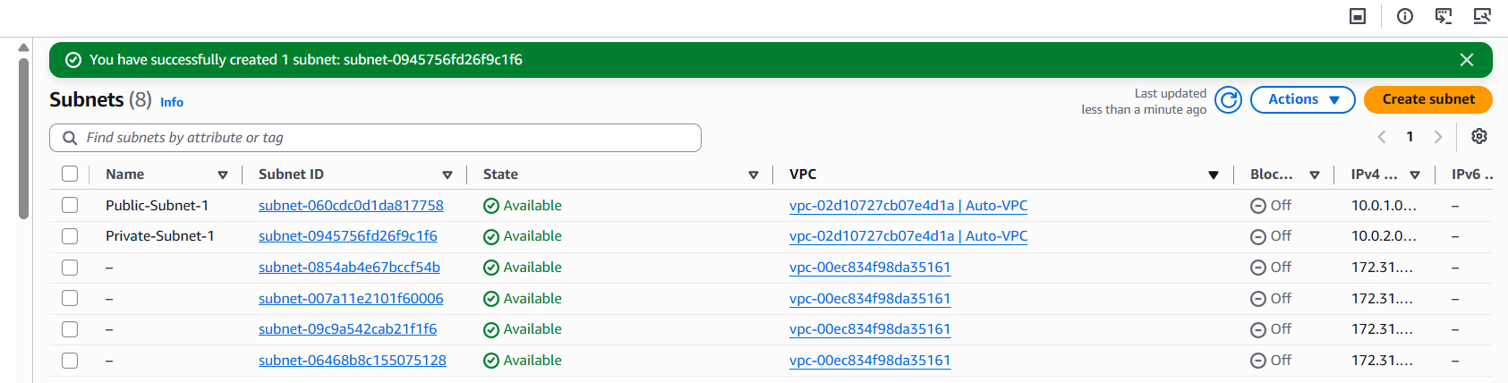
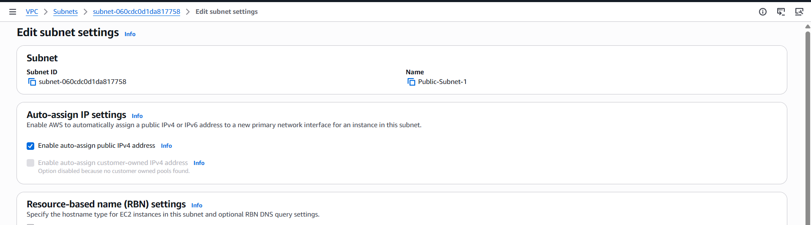

TASK 3: Attach an Internet Gateway to the VPC

Step 3.1 — Create the Internet Gateway
1. VPC console → Internet Gateways → Create internet gateway.
2. Name tag: AUTO-IGW.
3. Click Create internet gateway.

Step 3.2 — Attach It to the VPC
1. On the details page, click Actions → Attach to VPC.
2. Select AUTO-VPC → Attach internet gateway.
3. Confirm the State column shows Attached.
✅ Task 3 Complete: Lab-IGW is attached to Lab-VPC, enabling internet routing for the public subnet.
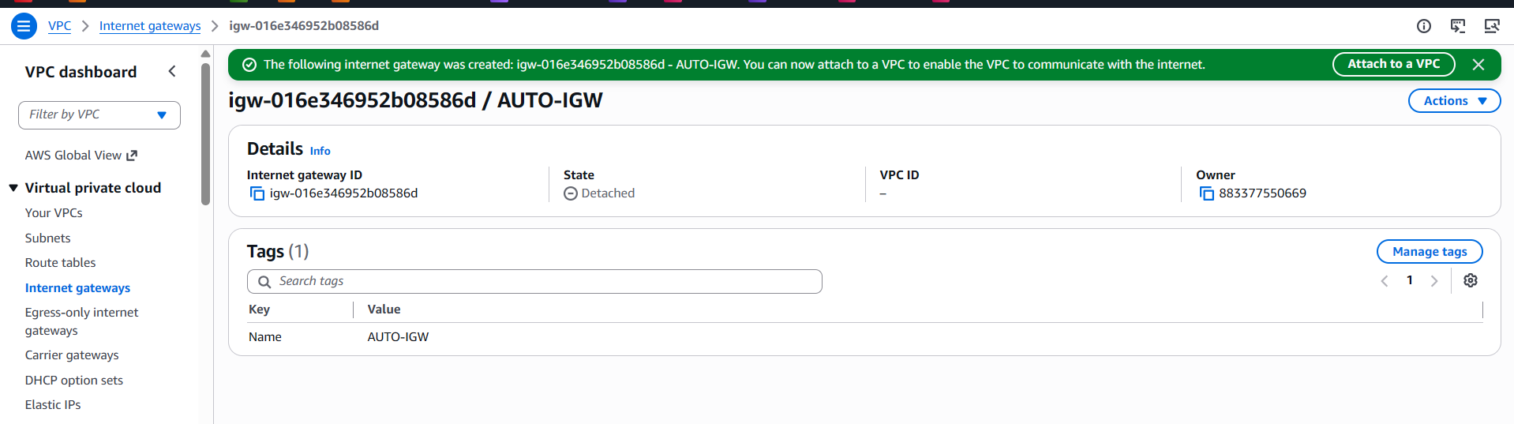
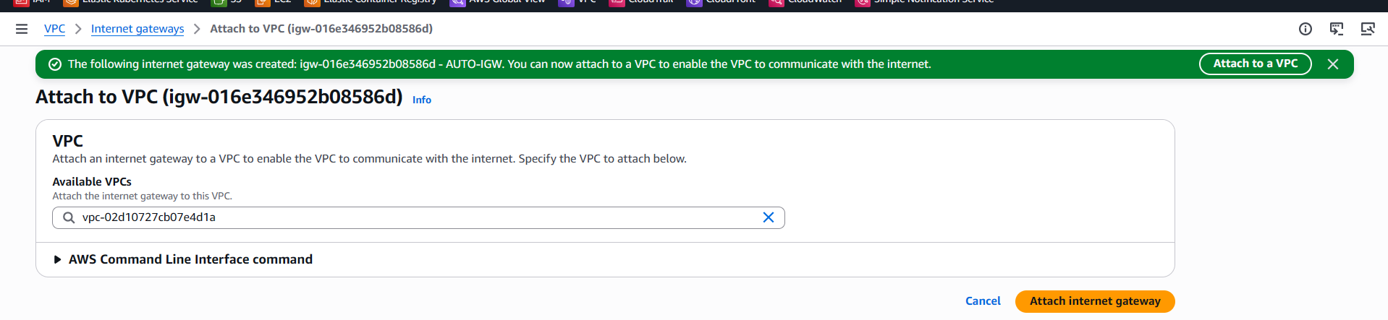

TASK 4: Create One Public Route Table and One Private Route Table

Step 4.1 — Create and Configure the Public Route Table
1. VPC console → Route Tables → Create route table.
2. Name tag: Public-RT. VPC: AUTO-VPC. Click Create route table.
3. Select Public-RT → Routes tab → Edit routes → Add route: Destination = 0.0.0.0/0, Target = Internet Gateway → Lab-IGW → Save changes.
4. Subnet associations tab → Edit subnet associations → check Public-Subnet-1 → Save associations.
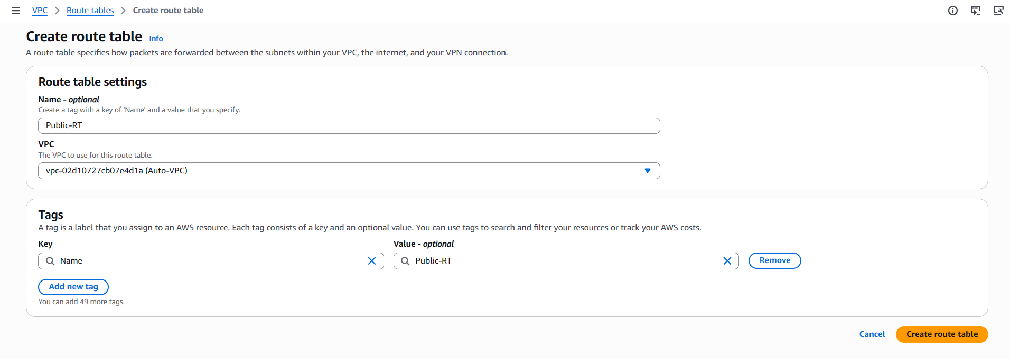
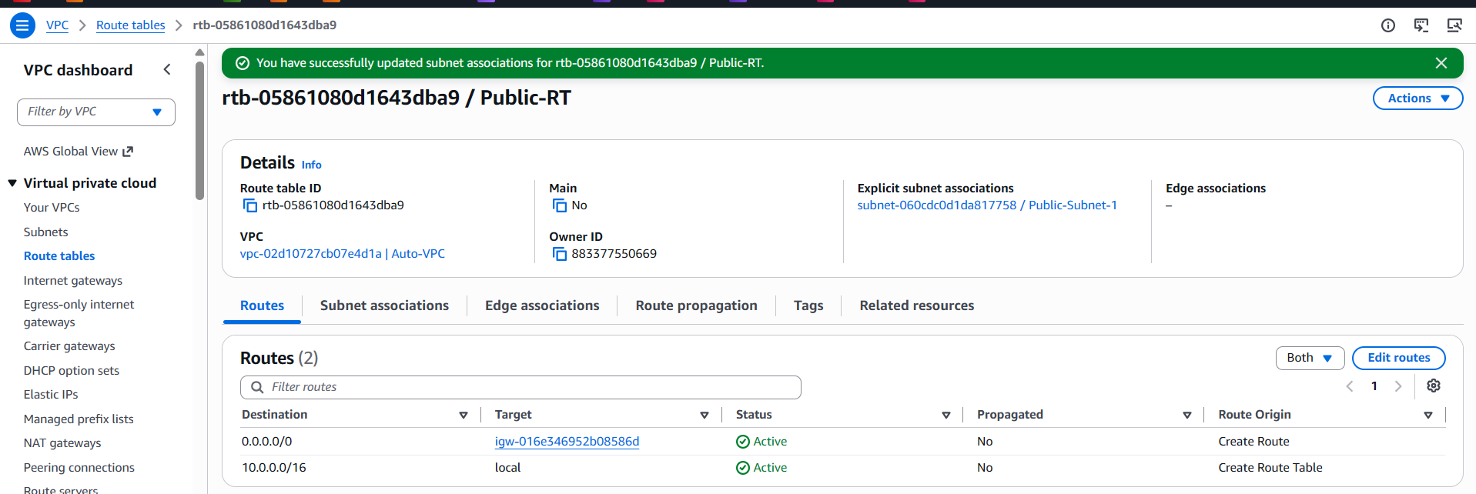

Step 4.2 — Create the Private Route Table
1. Create route table again.
2. Name tag: Private-RT. VPC: AUTO-VPC. Click Create route table.
3. Subnet associations tab → Edit subnet associations → check Private-Subnet-1 → Save associations.
4. Leave only the default local route for now — the 0.0.0.0/0 → NAT Gateway route is added in Task 5.
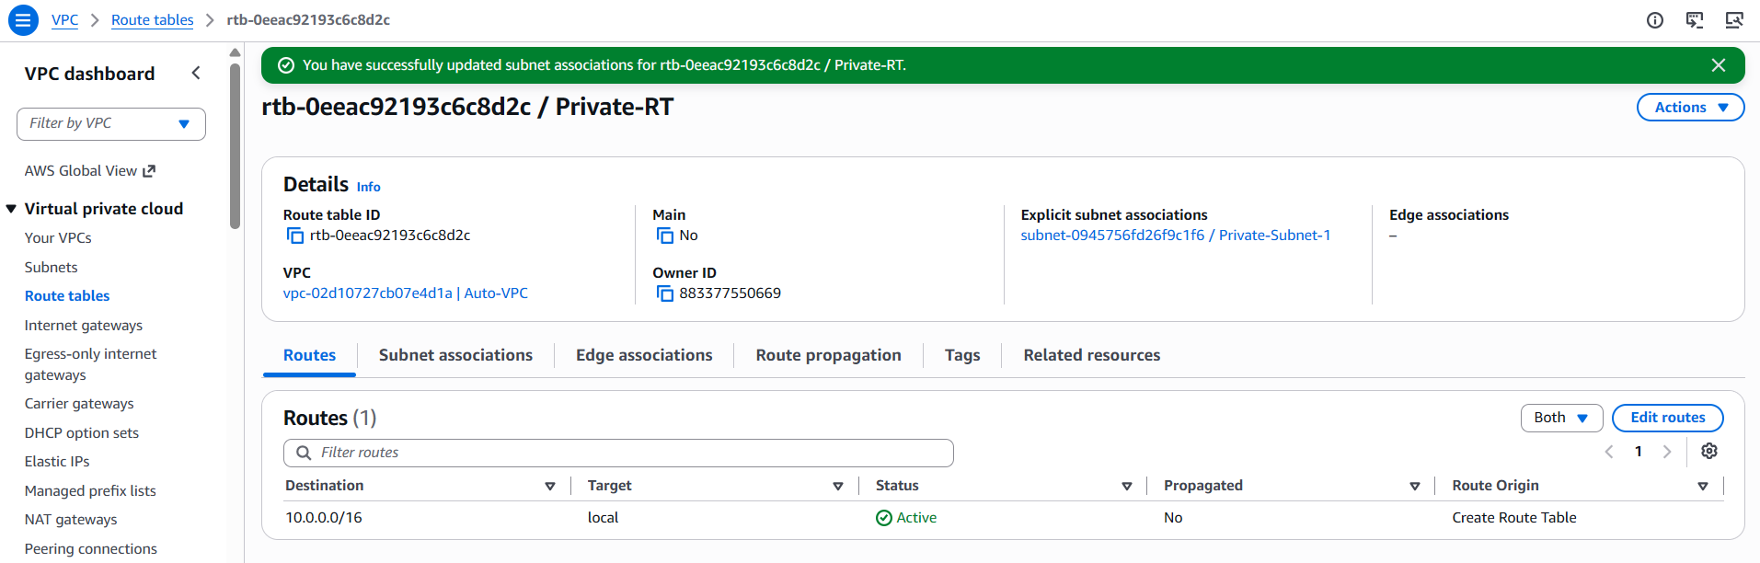

TASK 5: Deploy a NAT Gateway in the Public Subnet and Attach It to the Private Subnet

Step 5.1 — Allocate an Elastic IP
- VPC console → Elastic IPs → Allocate Elastic IP address → Allocate (default settings).

Step 5.2 — Create the NAT Gateway
1. VPC console → NAT Gateways → Create NAT gateway.
2. Name: AUTO-NAT-GW. Subnet: Public-Subnet-1 (a NAT Gateway must live in a public subnet). Connectivity type: Public.
3. Elastic IP allocation ID: select the EIP allocated in Step 5.1.
4. Click Create NAT gateway. Wait for State = Available (1–2 minutes).

Step 5.3 — Route Private Subnet Traffic Through the NAT Gateway
1. VPC console → Route Tables → select Private-RT → Routes tab → Edit routes.
2. Add route: Destination = 0.0.0.0/0, Target = NAT Gateway → Lab-NAT-GW.
3. Click Save changes.
✅ Task 5 Complete: Instances in Private-Subnet-1 can now reach the internet outbound (e.g., for yum/apt updates) via Lab-NAT-GW, without being directly reachable from the internet.
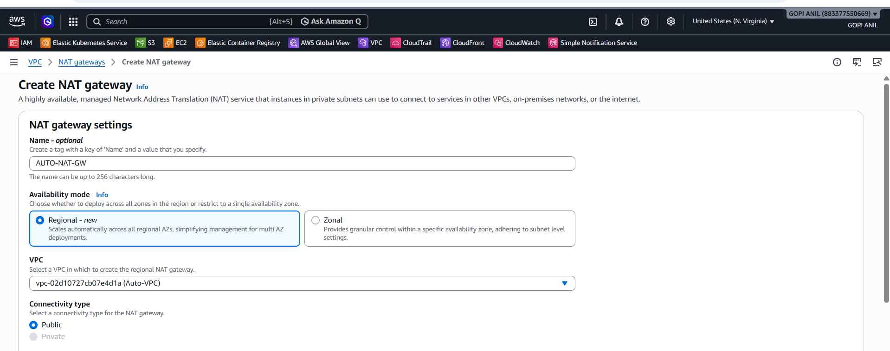
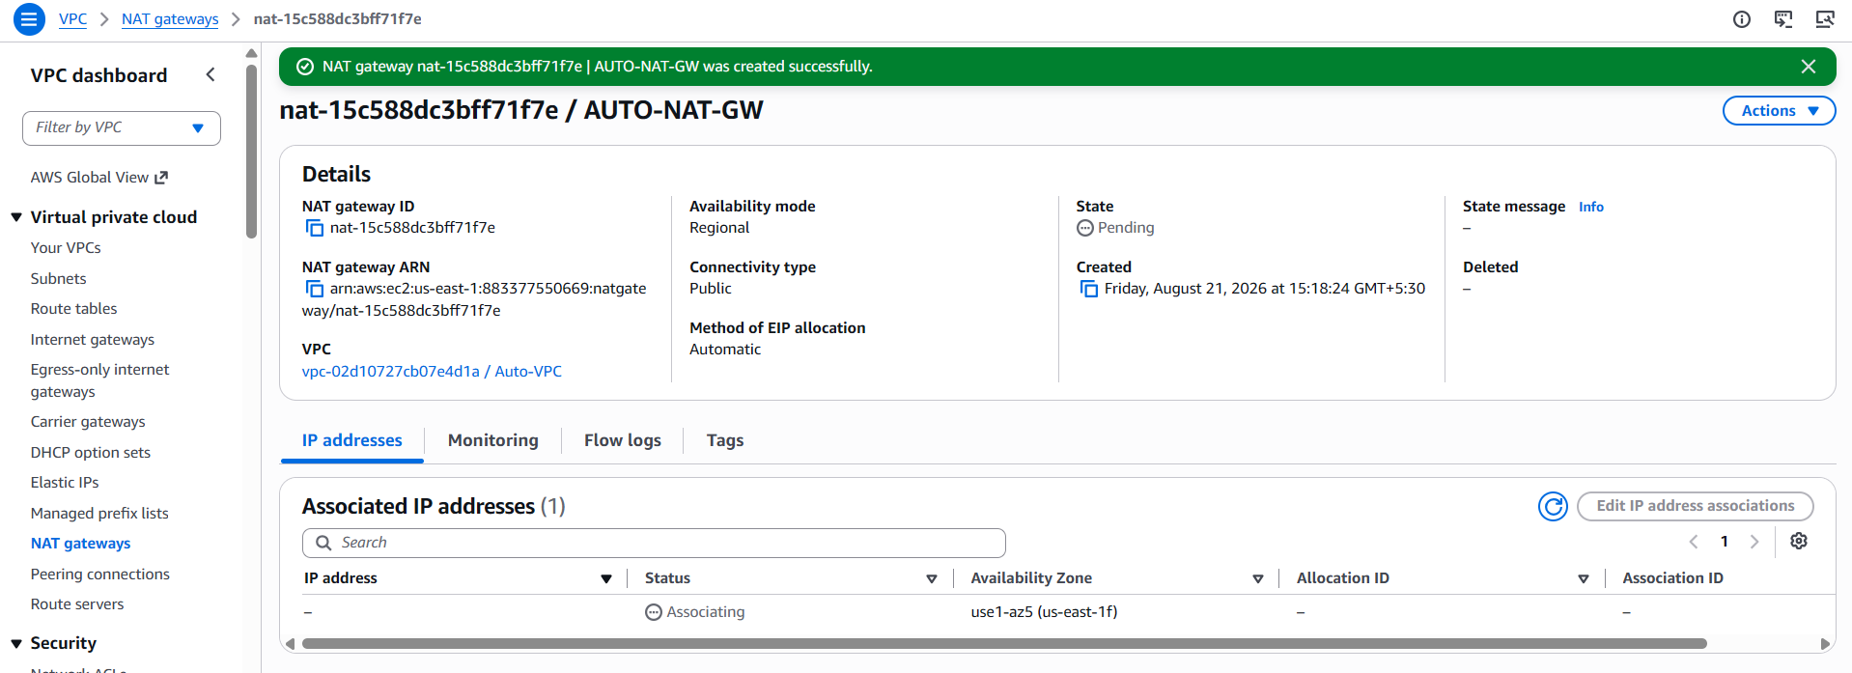

TASK 6: Create Two EC2 Instances — Public and Private

Step 6.1 — Create a Security Group for the Public Instance
1. EC2 console → Security Groups → Create security group.
2. Name: Public-Web-SG. VPC: AUTO-VPC.
3. Inbound rules: Allow SSH (22) from My IP; Allow HTTP (80) from 0.0.0.0/0.
4. Click Create security group.
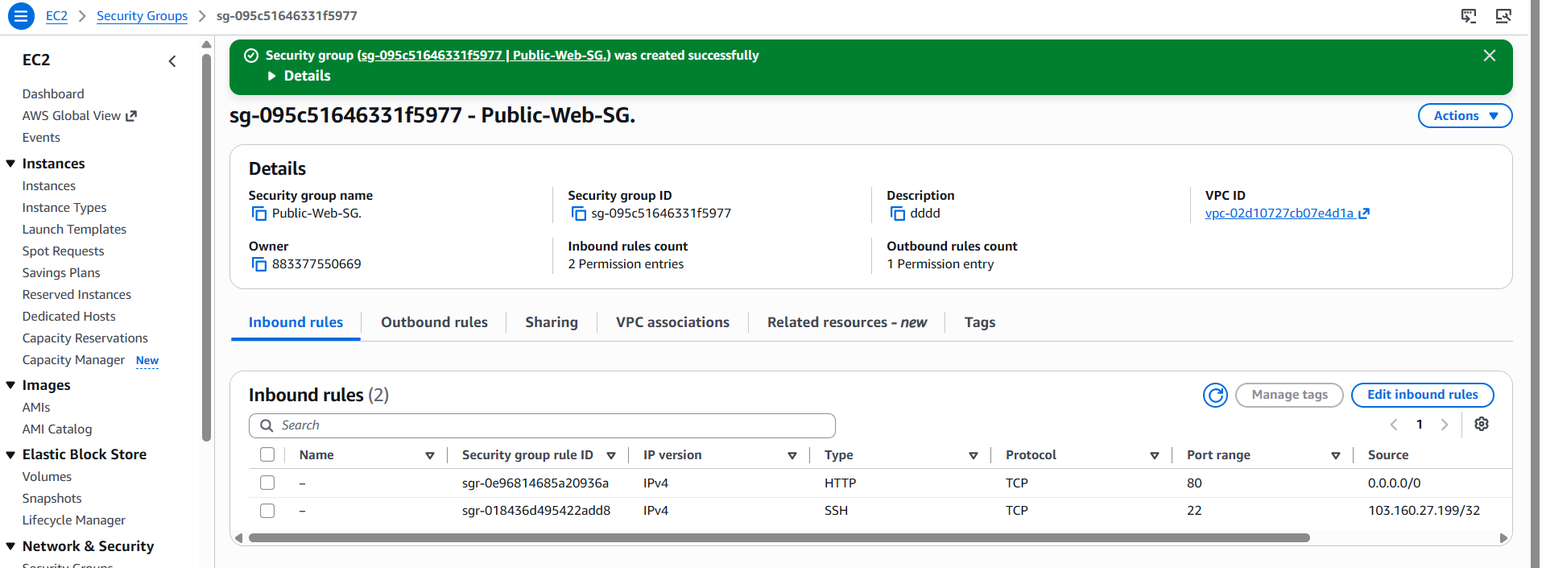

Step 6.2 — Create a Security Group for the Private Instance
1. Create security group again.
2. Name: Private-Web-SG. VPC: Lab-VPC.
3. Inbound rules: Allow SSH (22) from 10.0.1.0/24 (so only the public subnet, e.g., a bastion, can SSH in); Allow HTTP (80) from 10.0.0.0/16 (covers the ALB once its security group is created in Task 8 — this can be tightened to the ALB's security group specifically after Task 8).
4. Click Create security group.
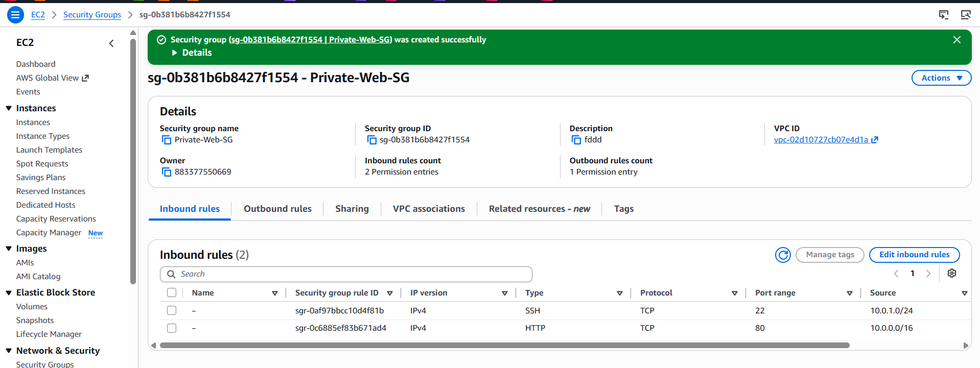

Step 6.3 — Launch the Public Instance
1. EC2 console → Instances → Launch instances.
2. Name: Public-Web-Instance. AMI: Amazon Linux 2023. Instance type: t2.micro (or t3.micro).
3. Key pair: select or create one.
4. Network settings → Edit: VPC = Lab-VPC; Subnet = Public-Subnet-1; Auto-assign public IP = Enable; Security group = select existing → Public-Web-SG.
5. Click Launch instance.

Step 6.4 — Launch the Private Instance
1. Launch instances again.
2. Name: Private-Web-Instance. AMI: Amazon Linux 2023. Instance type: t2.micro (or t3.micro).
3. Key pair: same as above.
4. Network settings → Edit: VPC = Lab-VPC; Subnet = Private-Subnet-1; Auto-assign public IP = Disable; Security group = select existing → Private-Web-SG.
5. Click Launch instance.

Step 6.5 — Verify
1. EC2 console → Instances → confirm Public-Web-Instance has a public IPv4 address and Private-Web-Instance does not.
2. Confirm both show Instance state = Running.
✅ Task 6 Complete: Public-Web-Instance (internet-reachable) and Private-Web-Instance (internal-only, outbound via NAT) are both running in Lab-VPC.
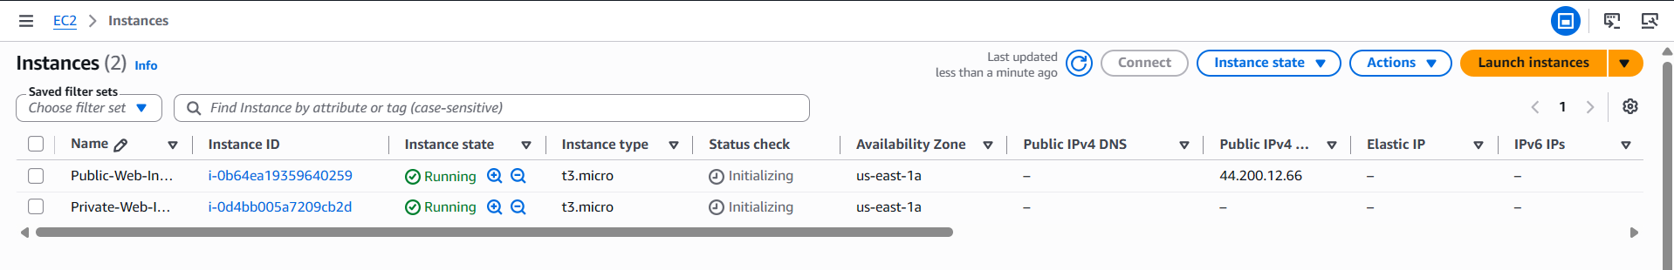

TASK 7: Deploy Apache on Both EC2 Instances with a Sample index.html

Step 7.1 — Connect to the Public Instance and Install Apache
1. EC2 console → select Public-Web-Instance → Connect → EC2 Instance Connect (or SSH using the key pair and its public IP).
2. Run the following commands:
sudo yum update -y
sudo yum install -y httpd
sudo systemctl enable --now httpd
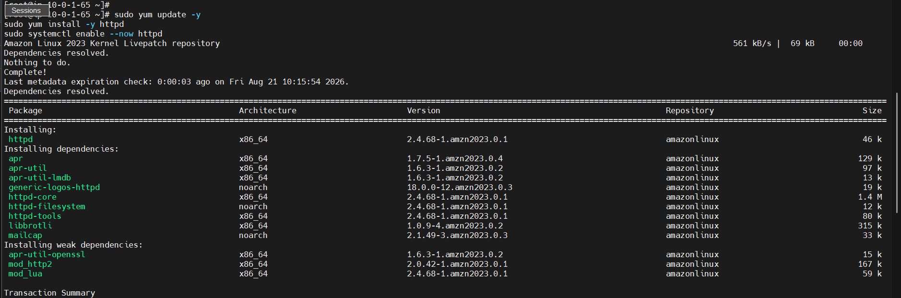
3. Create a sample page:
echo "<h1>Hello from Public-Web-Instance ($(hostname -f))</h1>" | sudo tee /var/www/html/index.html

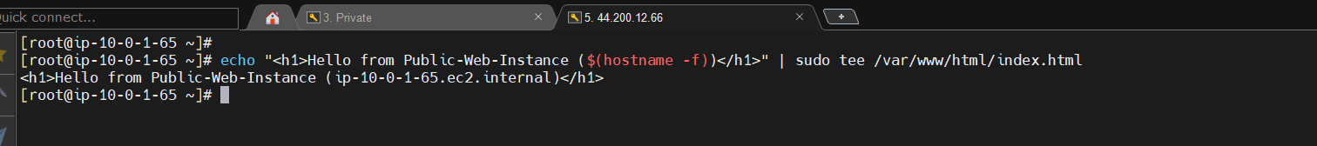4. Test locally: curl http://localhost — confirm the HTML is returned.
5. From a browser, open http://<public-IP-of-Public-Web-Instance> and confirm the page loads.


Step 7.2 — Connect to the Private Instance and Install Apache
1. Since Private-Web-Instance has no public IP, connect to it either via Session Manager (EC2 console → Connect → Session Manager, requires an SSM IAM instance profile) or by SSH-hopping through Public-Web-Instance.
2. Run the same install commands as Step 7.1:
sudo yum update -y
sudo yum install -y httpd
sudo systemctl enable --now httpd

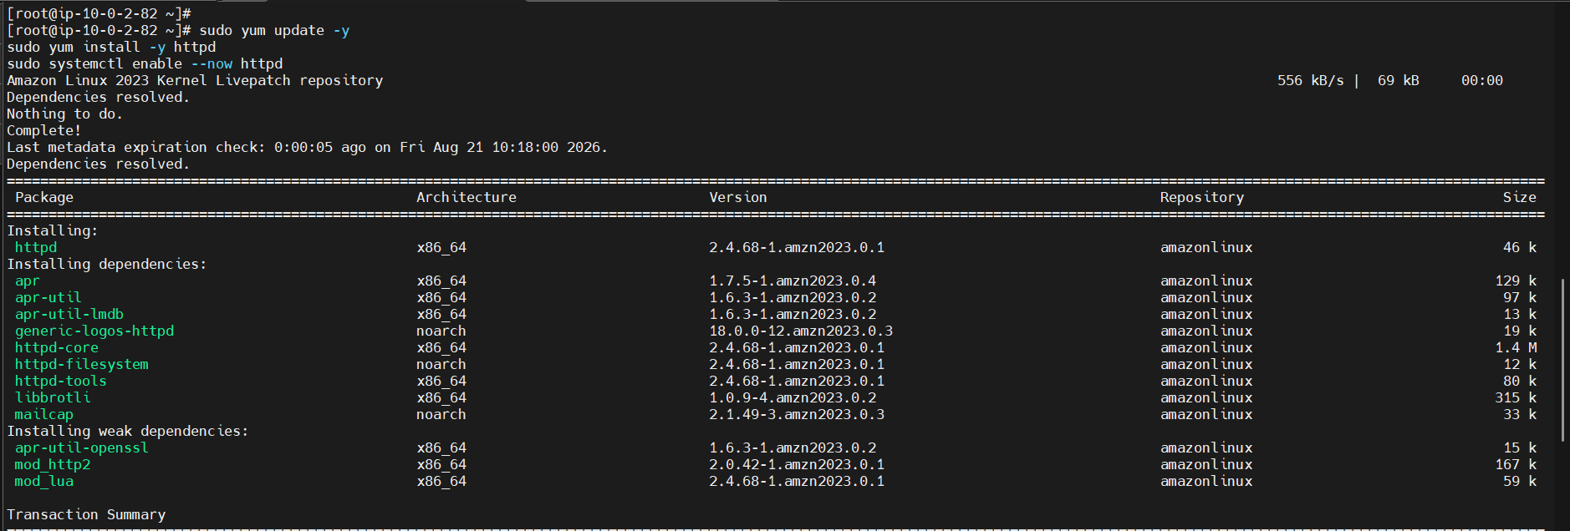3. Create its sample page:
echo "<h1>Hello from Private-Web-Instance ($(hostname -f))</h1>" | sudo tee /var/www/html/index.html
4. Test locally: curl http://localhost — confirm the HTML is returned. This instance is not reachable directly from the internet — the ALB in Task 8 will expose it.
✅ Task 7 Complete: Apache is installed, enabled, and serving a distinct sample index.html on both instances.
Note: For repeatable deployments, the same install commands can be placed in the EC2 User data field at launch time instead of run manually after the fact — useful once this setup is turned into a Launch Template for Auto Scaling in Task 12.

TASK 8: Create an Application Load Balancer and Attach It to Both Instances
An Application Load Balancer requires at least two subnets in two different Availability Zones. Since the base design only has one public subnet (Task 2), a second public subnet is added here specifically to satisfy that requirement.

Step 8.1 — Add a Second Public Subnet for the ALB
1. VPC console → Subnets → Create subnet.
2. VPC ID: auto-VPC. Subnet name: Public-Subnet-2. Availability Zone: us-east-1b. IPv4 CIDR: 10.0.3.0/24.
3. Click Create subnet, then select it → Actions → Edit subnet settings → enable auto-assign public IPv4 address → Save.
4. VPC console → Route Tables → select Public-RT → Subnet associations → Edit subnet associations → also check Public-Subnet-2 → Save associations (so it also routes through Lab-IGW).
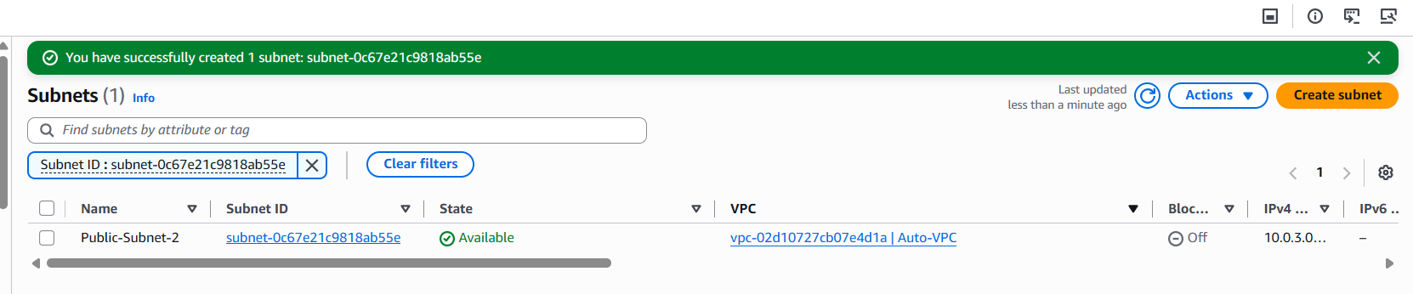

Step 8.2 — Create a Security Group for the ALB
1. EC2 console → Security Groups → Create security group.
2. Name: ALB-SG. VPC: Lab-VPC.
3. Inbound rules: Allow HTTP (80) from 0.0.0.0/0.
4. Click Create security group.
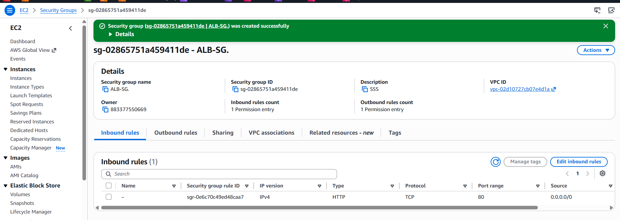

Step 8.3 — Create a Target Group
1. EC2 console → Target Groups → Create target group.
2. Target type: Instances. Target group name: Web-Target-Group.
3. Protocol: HTTP, Port: 80. VPC: Lab-VPC.
4. Health check path: / (default).
5. Click Next. Register targets: select both Public-Web-Instance and Private-Web-Instance → Include as pending below → Create target group.
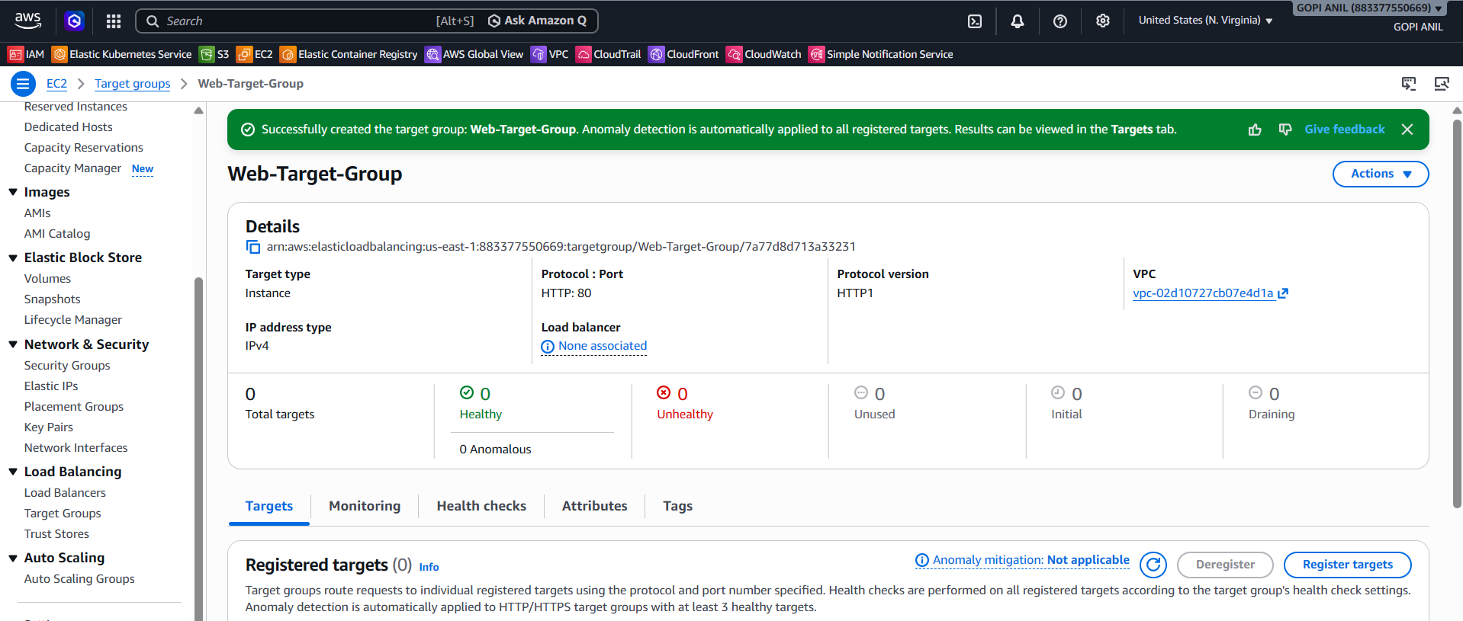

Step 8.4 — Create the Application Load Balancer
1. EC2 console → Load Balancers → Create load balancer → Application Load Balancer → Create.
2. Name: Auto-App-ALB. Scheme: Internet-facing. IP address type: IPv4.
3. Network mapping: VPC = Lab-VPC; select Availability Zones us-east-1a (Public-Subnet-1) and us-east-1b (Public-Subnet-2).
4. Security groups: select ALB-SG (remove the default SG if pre-selected).
5. Listeners and routing: Listener HTTP:80 → Default action: forward to Web-Target-Group.
6. Click Create load balancer. Wait for State = Active (a few minutes).
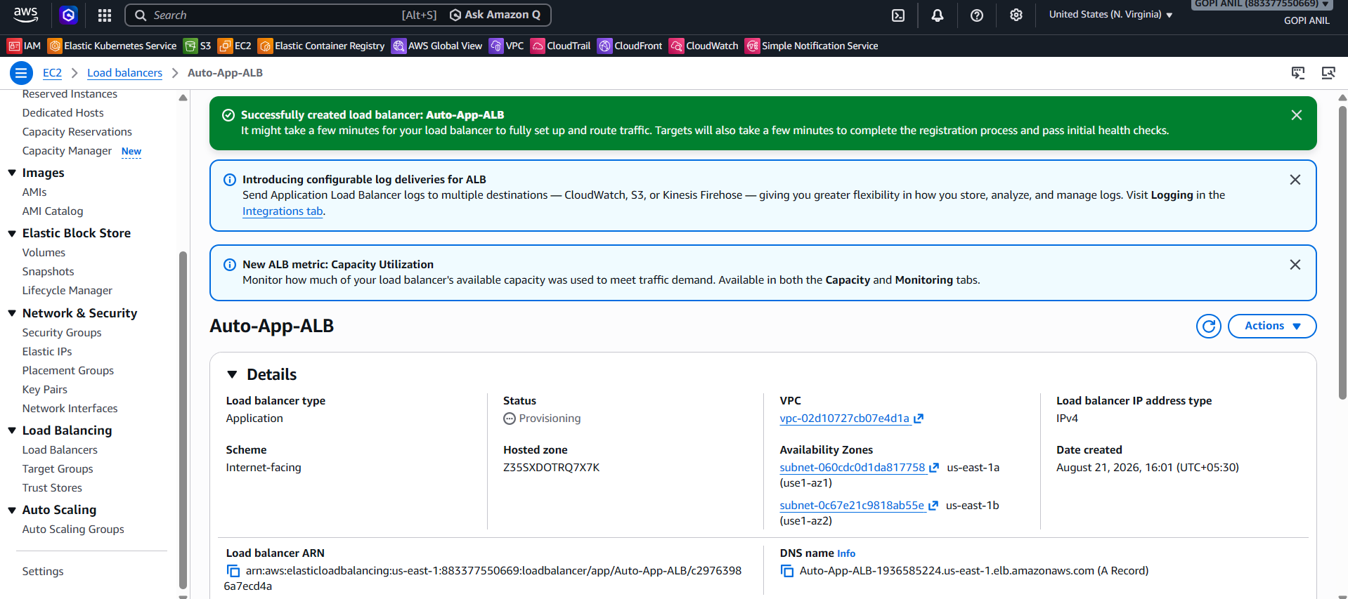

Step 8.5 — Allow the ALB to Reach the Private Instance
1. EC2 console → Security Groups → select Private-Web-SG → Inbound rules → Edit inbound rules.
2. Update (or add) the HTTP (80) rule's source to be ALB-SG specifically (instead of the broader 10.0.0.0/16 used in Task 6), following least-privilege practice → Save rules.

Step 8.6 — Verify
1. Copy the ALB's DNS name from the Load Balancers page, e.g., Lab-App-ALB-123456789.us-east-1.elb.amazonaws.com.
2. Open it in a browser several times (or refresh) and confirm responses alternate between “Hello from Public-Web-Instance…” and “Hello from Private-Web-Instance…”, proving both targets are being load-balanced.
3. Target Groups → Web-Target-Group → Targets tab → confirm both instances show Health status = healthy.
✅ Task 8 Complete: Lab-App-ALB distributes HTTP traffic across both the public and private EC2 instances, and the private instance is now reachable only via the load balancer.



TASK 9: Store ALB Access Logs in S3

Step 9.1 — Create the Logs Bucket
1. S3 console → Create bucket.
2. Bucket name: lab-alb-access-logs-2026 (must be globally unique).
3. Region: US East (N. Virginia) us-east-1 — must be the same Region as the ALB.
4. Leave Block all public access ON. Click Create bucket.
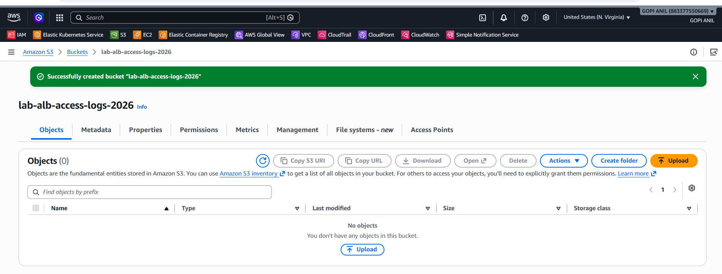

Step 9.2 — Attach a Bucket Policy Allowing the ELB Service to Write Logs
1. Select the bucket → Permissions tab → Bucket policy → Edit.
2. Paste the policy below. The Principal account ID (127311923021 in this example) is AWS's fixed Elastic Load Balancing log-delivery account for the us-east-1 Region — this ID changes per Region, so verify the correct one in the AWS documentation if deploying elsewhere:
{
"Version": "2012-10-17",
"Statement": [
{
"Effect": "Allow",
"Principal": {
"AWS": "arn:aws:iam::127311923021:root"
},
"Action": "s3:PutObject",
"Resource": "arn:aws:s3:::lab-alb-access-logs-2026/AWSLogs/*"
}
]
}
- Click Save changes.
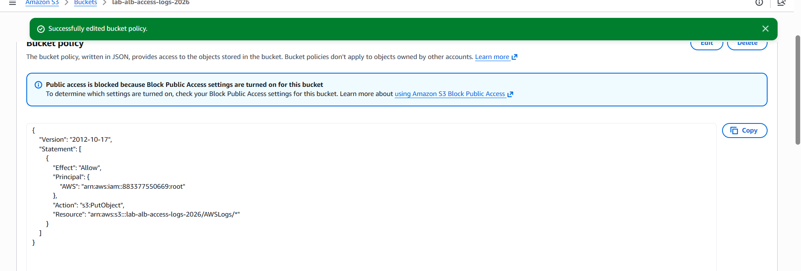

Step 9.3 — Enable Access Logging on the ALB
1. EC2 console → Load Balancers → select Lab-App-ALB → Attributes tab → Edit.
2. Monitoring → Access logs: toggle On.
3. S3 URI: s3://lab-alb-access-logs-2026 (optionally add a prefix, e.g., s3://lab-alb-access-logs-2026/lab-app-alb).
4. Click Save changes.
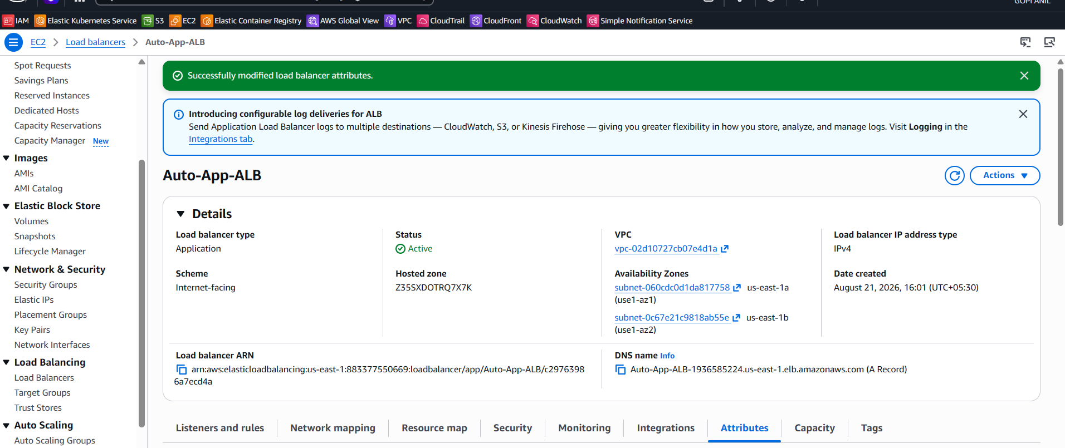

Step 9.4 — Verify
1. Generate some traffic by refreshing the ALB DNS name a few times.
2. Wait 5–10 minutes, then check the S3 bucket under AWSLogs/<account-id>/elasticloadbalancing/us-east-1/<year>/<month>/<day>/ for delivered .log.gz files.
✅ Task 9 Complete: Lab-App-ALB delivers access logs to lab-alb-access-logs-2026 for traffic auditing and troubleshooting.

TASK 10: Store VPC Flow Logs in a CloudWatch Logs Group

Step 10.1 — Create the Flow Log
1. VPC console → Your VPCs → select Lab-VPC → Flow logs tab → Create flow log.
2. Filter: All (captures both ACCEPT and REJECT traffic).
3. Maximum aggregation interval: 1 minute (more granular) or 10 minutes (lower cost).
4. Destination: Send to CloudWatch Logs.
5. Destination log group: Create new → name it /vpc/lab-vpc-flow-logs (or select an existing group).
6. IAM role: Create new role (the console generates one with the correct trust and permissions) — name it, e.g., Lab-VPC-FlowLogs-Role.
7. Click Create flow log.
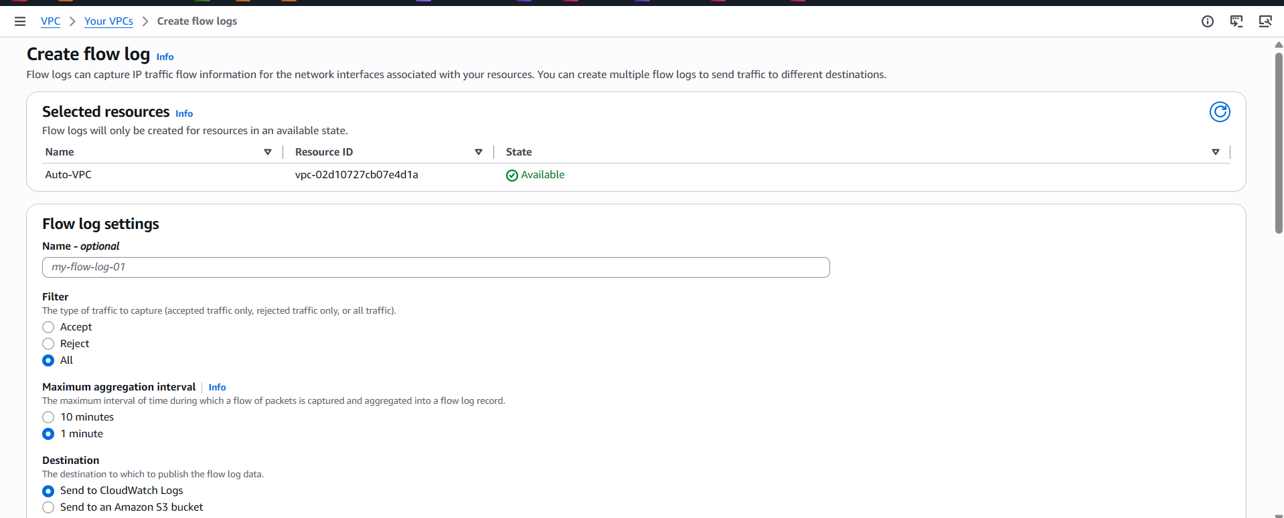
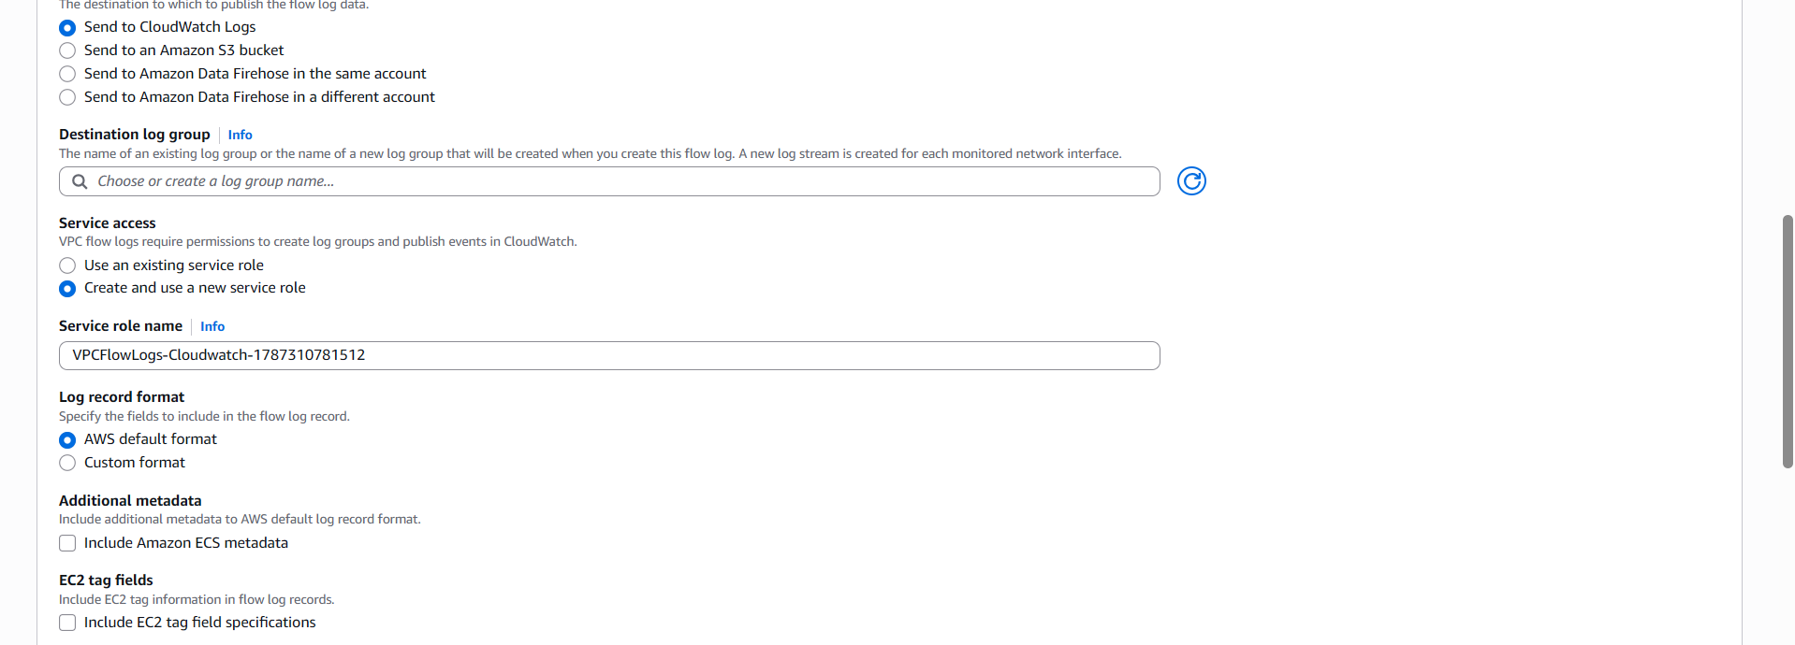
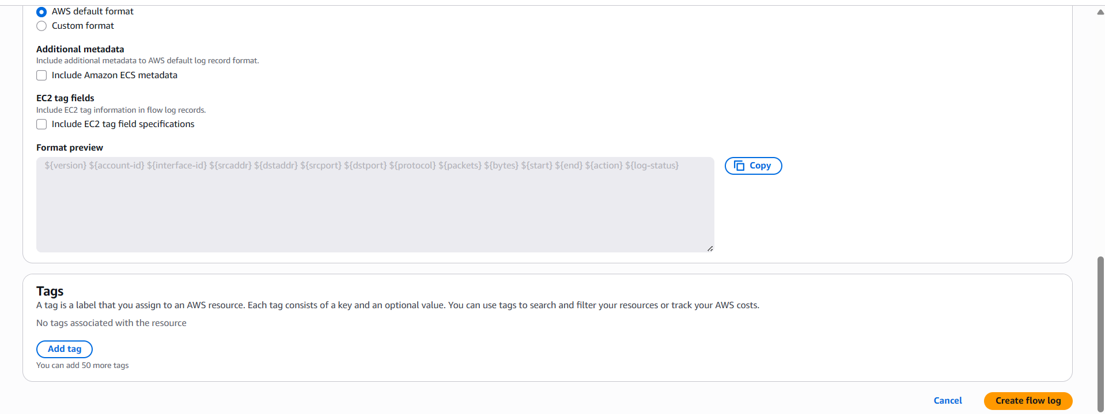
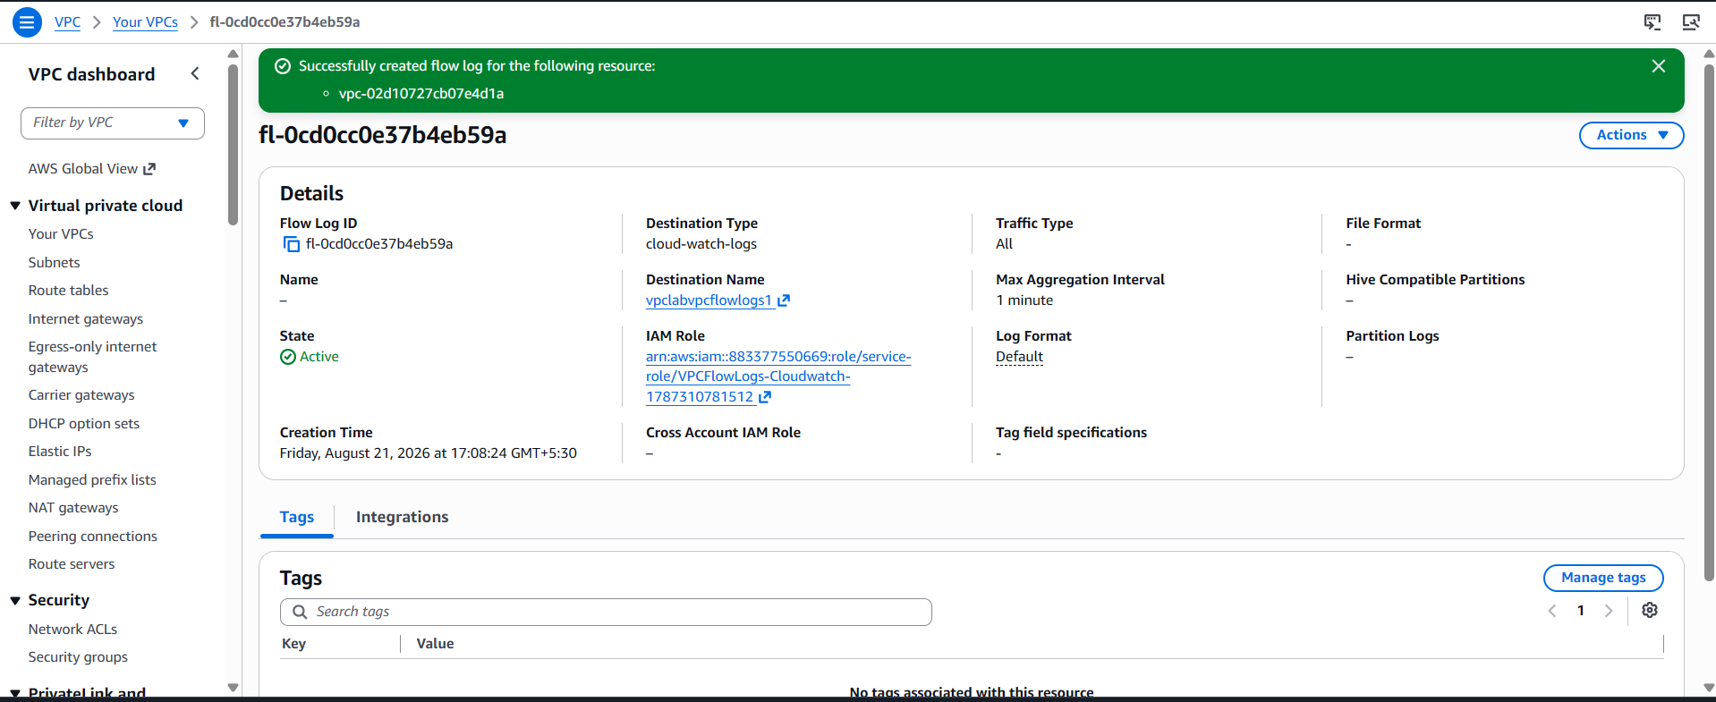

TASK 11: Create Monitoring Dashboards for CPU Utilization and the Apache Service

Step 11.1 — Install the CloudWatch Agent (for the Apache Process Check)
- Attach an IAM role with the CloudWatchAgentServerPolicy managed policy to both EC2 instances (EC2 console → instance → Actions → Security → Modify IAM role).
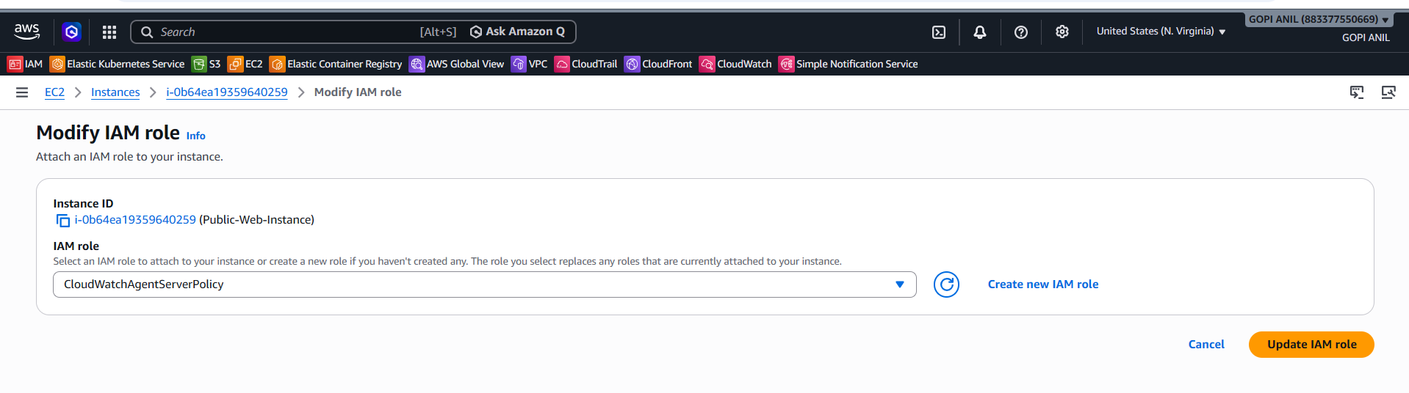
2. On each instance, install the agent:
sudo yum install -y amazon-cloudwatch-agent
3. Create /opt/aws/amazon-cloudwatch-agent/etc/config.json with a procstat block watching httpd:
{
"metrics": {
"namespace": "CWAgent",
"metrics_collected": {
"procstat": [
{
"pattern": "httpd",
"measurement": ["pid_count"]
}
]
}
}
}
4. Start the agent with this config on each instance:
sudo /opt/aws/amazon-cloudwatch-agent/bin/amazon-cloudwatch-agent-ctl -a fetch-config -m ec2 -s -c file:/opt/aws/amazon-cloudwatch-agent/etc/config.json

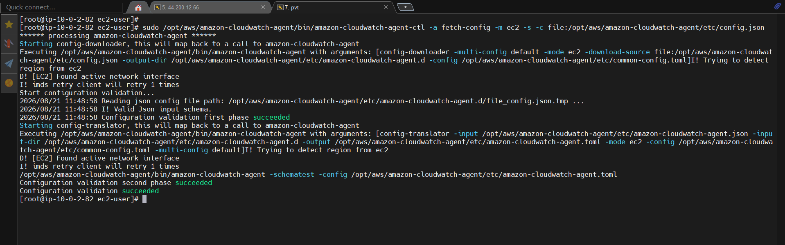

Step 11.2 — Create the Dashboard
1. CloudWatch console → Dashboards → Create dashboard.
2. Dashboard name: Web-Tier-Dashboard → Create dashboard.
3. Add widget → Line → Metrics → EC2 → Per-Instance Metrics → select CPUUtilization for both Public-Web-Instance and Private-Web-Instance → Create widget.
4. Add widget → Number (or Line) → Metrics → CWAgent → procstat_lookup_pid_count for pattern=httpd, for both instances → Create widget.
5. Add widget → Line → Metrics → ApplicationELB → select RequestCount and HealthyHostCount for Lab-App-ALB / Web-Target-Group → Create widget.
6. Arrange the widgets and click Save dashboard.
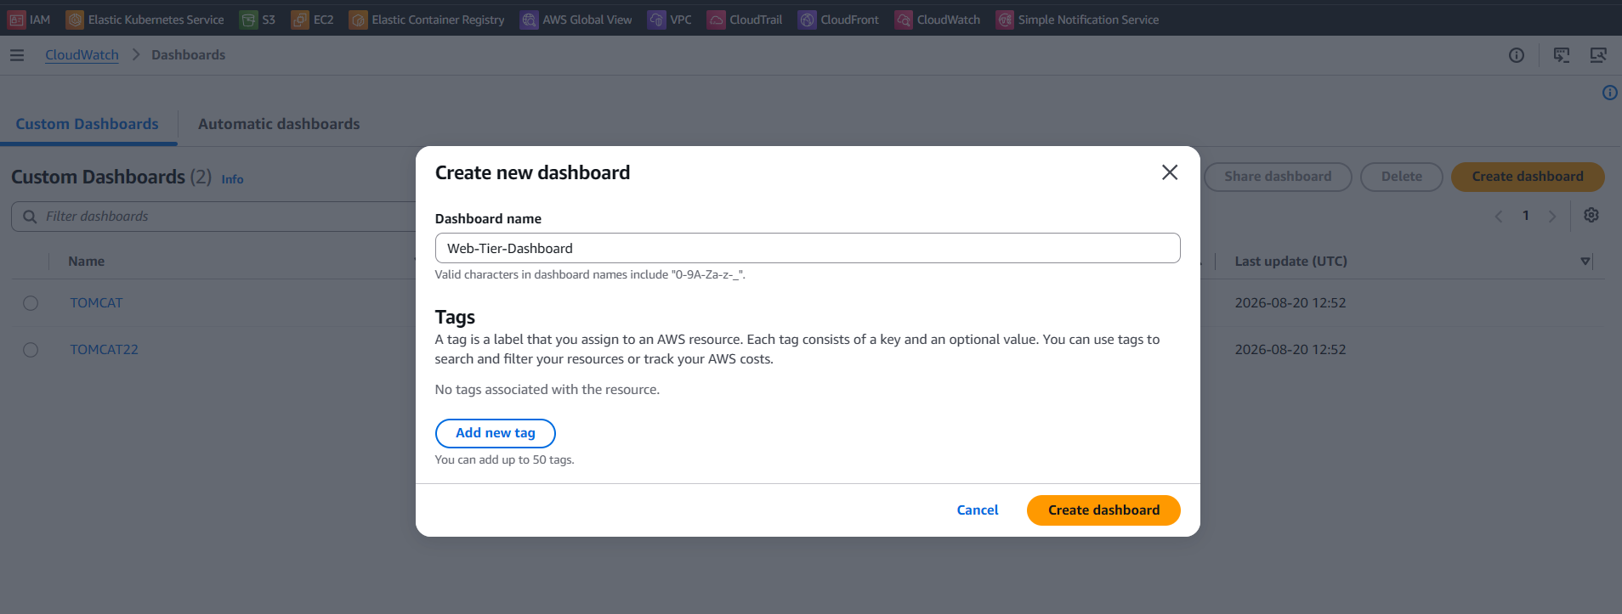
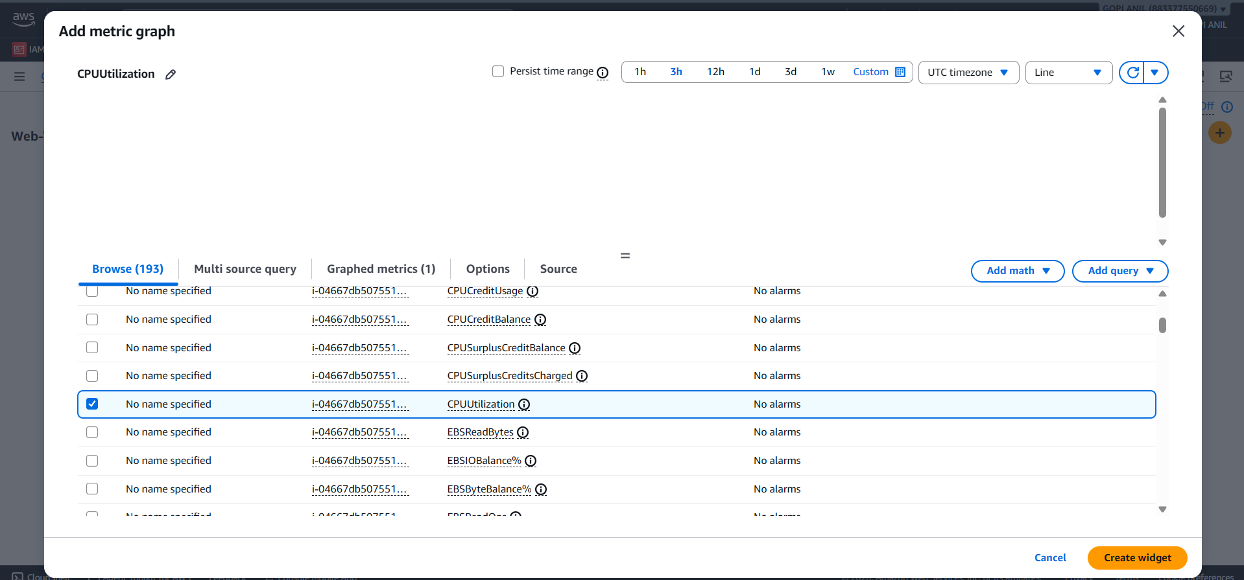

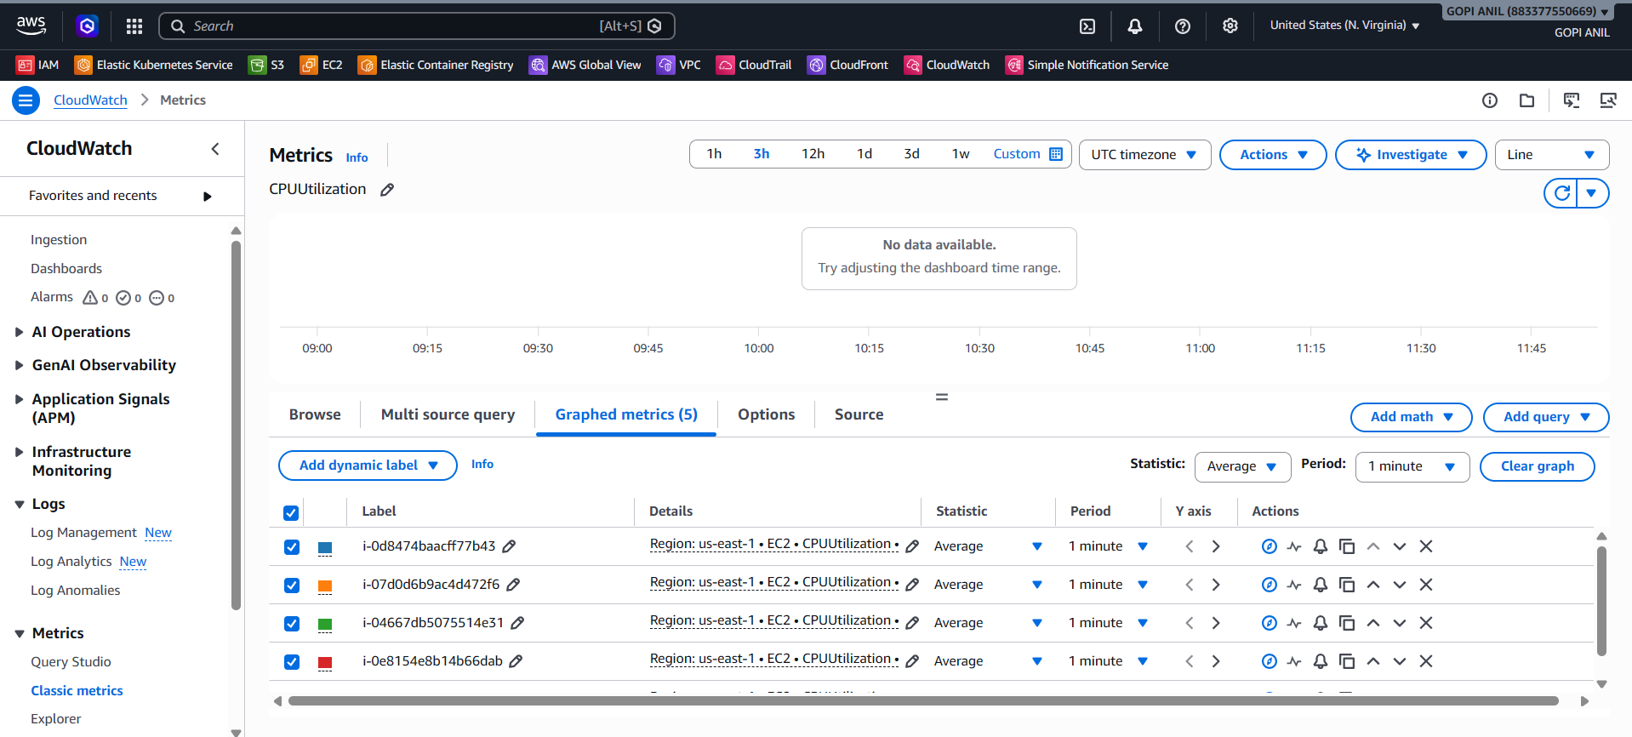

Step 11.3 — Verify
1. Confirm all widgets populate with live data within a few minutes: CPU trends, Apache pid_count = 1 on both instances, and ALB request/healthy-host counts.
✅ Task 11 Complete: Web-Tier-Dashboard gives a single view of CPU utilization, Apache process health, and ALB traffic/health across both instances.

TASK 12: Trigger Auto Scaling to Launch a New Instance When CPU > 70%
Goal: When average CPU utilization across the web tier exceeds 70%, automatically launch an additional instance and register it with the same ALB target group. This requires converting the manually-built web tier into a Launch Template + Auto Scaling Group, since Auto Scaling manages its own fleet of instances rather than the two standalone ones created in Task 6.

Step 12.1 — Create a Launch Template
1. EC2 console → Launch Templates → Create launch template.
2. Name: Web-Tier-Launch-Template.
3. AMI: Amazon Linux 2023. Instance type: t2.micro (or t3.micro).
4. Key pair: same as Task 6.
5. Network settings: Security group = Private-Web-SG (new instances will launch into the private subnet, matching the architecture's private application tier).
6. IAM instance profile: attach the same CloudWatchAgentServerPolicy role used in Task 11, so new instances also report metrics automatically.
7. Advanced details → User data: paste the following so every new instance self-installs Apache, a sample page, and the CloudWatch Agent on first boot:
#!/bin/bash
yum update -y
yum install -y httpd amazon-cloudwatch-agent
systemctl enable --now httpd
echo "<h1>Hello from $(hostname -f) (Auto Scaled)</h1>" > /var/www/html/index.html
cat <<'EOF' > /opt/aws/amazon-cloudwatch-agent/etc/config.json
{
"metrics": {
"namespace": "CWAgent",
"metrics_collected": {
"procstat": [ { "pattern": "httpd", "measurement": ["pid_count"] } ]
}
}
}
EOF
/opt/aws/amazon-cloudwatch-agent/bin/amazon-cloudwatch-agent-ctl -a fetch-config -m ec2 -s -c file:/opt/aws/amazon-cloudwatch-agent/etc/config.json
8. Click Create launch template.

Step 12.2 — Create the Auto Scaling Group
1. EC2 console → Auto Scaling Groups → Create Auto Scaling group.
2. Name: Web-Tier-ASG. Launch template: Web-Tier-Launch-Template.
3. VPC: Lab-VPC. Subnets: Private-Subnet-1 (add a second private subnet in another AZ here for high availability if desired — omitted from this lab's base design for simplicity).
4. Load balancing: Attach to an existing load balancer → choose your existing target group → Web-Target-Group.
5. Health checks: enable ELB health checks in addition to EC2 (so the ASG replaces instances that fail ALB health checks, not just EC2 status checks).
6. Group size: Desired capacity = 1, Minimum capacity = 1, Maximum capacity = 3.
7. Scaling policies: choose None for now — the policy is created explicitly in Step 12.3 for clarity.
8. Click Next through the remaining pages (notifications/tags optional) and click Create Auto Scaling group.

Step 12.3 — Create the Target-Tracking / CPU Scaling Policy
1. Open Web-Tier-ASG → Automatic scaling tab → Create dynamic scaling policy.
2. Policy type: Target tracking scaling.
3. Metric type: Average CPU utilization.
4. Target value: 70.
5. Instances need: 300 seconds warm-up before contributing to the metric (default).
6. Click Create.
7. (This single target-tracking policy automatically creates and manages the underlying CloudWatch alarms for scale-out when CPU > 70% and scale-in when it drops well below 70%, launching additional instances up to the Maximum capacity of 3 as needed.)

Step 12.4 — Test the Scaling Policy
1. SSH/Session Manager into the running ASG instance and generate load:
sudo yum install -y stress && stress --cpu 2 --timeout 600
2. Watch Web-Tier-ASG → Activity tab — within a few minutes a new scaling activity should appear, launching a second instance once average CPU exceeds 70%.
3. Confirm the new instance is automatically registered as a healthy target in Web-Target-Group and appears in the Web-Tier-Dashboard from Task 11.
4. Stop the stress command; once CPU drops and stays low, confirm the ASG scales back in toward the Minimum capacity after the cooldown period.
✅ Task 12 Complete: Web-Tier-ASG automatically launches additional Apache-serving instances whenever average CPU exceeds 70%, registers them with the ALB, and scales back in once load subsides.

